Exaple of the activity output from students

Note: The examples given here are for the disturbance of choice (disturbance # 5 in Supplemental Material 4), that challenged the students to make decisions about the kind of disturbance they wanted to subject the ecosystem to, as well as the parameters of that disturbance.

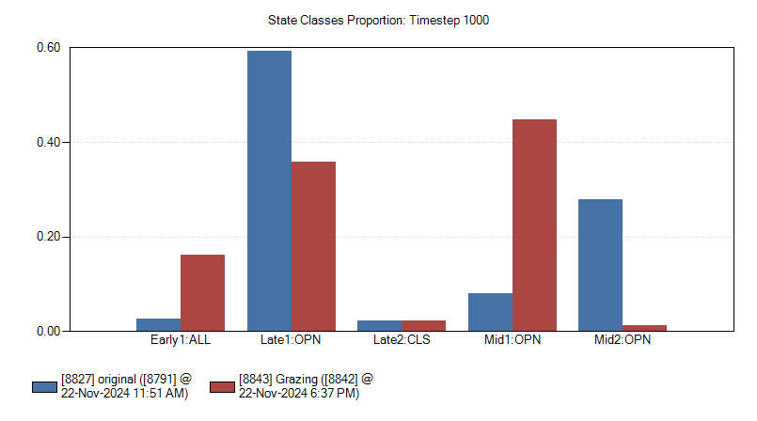
Fig 1. A graph showing outcome of grazing as a disturbance that a student selected for their disturbance of choice.

Fig 2. A graph showing outcome of a cigarette butt fire as a disturbance that a student selected for their disturbance of choice.

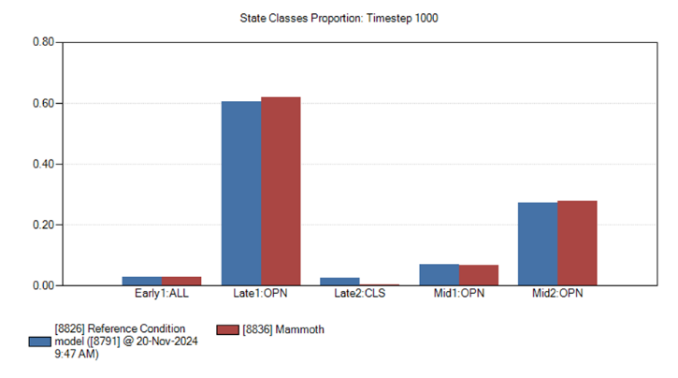
Fig 3. A graph showing outcome of a mammoth invasion as a disturbance that a student selected for their disturbance of choice.

Example of student responses to questions
Questions for the disturbance of choice.
- What was your disturbance? (1 pt).
- What successional stage did you move your system from, AND which one did you move it to? (1 pt).
- What was your return interval? (1 pt).
- In which successional stages did you notice the biggest change? (1 pt)
- Can you explain what your disturbance might have done to bring about the change in the stage you indicated in 4 above (2 pts).

Example responses for disturbance of choice.
Responses for Fig 1 above (grazing).
- My disturbance was grazing.
- I moved my system from Mid2 OPN to Early1ALL.
- My return interval was .5, or 2 years.
- The greatest changes happened in Late1 OPN and Mid1 OPN
- Since grazing removed a lot of the Mid2 succession, Mid1 really took off because of the reduced competition from older vegetation. Late1 was a lot lower than the original system, most likely because vegetation in Mid2 that normally would have matured to become Late1 were killed off.

Responses for Fig 2 above (cigarette butt fire).
- Fire started with a loose cigarette.
- Moved from Late2 CLS to Early1All, as I imagine a large fire would tend to do.
- Return interval of 5 years – people need to stop dropping their cigarettes on the ground!
- Late2 CLS was completely annihilated, with a decent increase in the proportion of Mid1 OPN and Mid2 OPN.
- Large fires and late stage vegetation do not typically get along well. Similar to the previous fire, late stage vegetation is knocked back in favor of more open early-mid succession vegetation. I was trying to create a more severe disaster, but my model would not let me cause untold ecological devastation! = (

Responses for Fig 3 above (mammoth invasion).
- My chosen disturbance was the return of wooly mammoths.
- I moved the system from Late2Closed to Mid1Open.
- The return interval for the mammoths was every other year (.5).
- I noticed the biggest change happening in the Late2Closed system, showing a near total decrease in its proportion.
- I think that grazing from mammoths would open up the canopy in forests, decreasing the amount of closed canopy species, and slightly increasing the mid-successional proportion of species, if at all.

Additional Note on products
SyncroSim Cloud (https://cloud.syncrosim.com/) is another place where modeling teams host various models and model outputs. Any user can upload and explore the models, as well as view outputs, but they cannot manipulate the models. Users do not have to install anything to access the site or view the products. This may be an option for instructors in situations where installing software is problematic.

